Week 4 Reading
Complete the following reading early in the week:
- Week 4 online lectures.
- From the textbook, Modeling a Character in 3ds Max:
  - Chapter 12: Mapping the Head
  - Chapter 13: Mapping the Rest of the Callisto
- Review the textbook 3ds Max 2010 Bible, as needed to reinforce and expand on the concepts and techniques required for this week’s assignments.
Week 4 Assignments Overview
Assignment Summary | Due Date
Assignment 1: Discussion Questions | Tuesday, April 27, 2010
Assignment 2: Final Project—Modeling the Level | Tuesday, April 27, 2010
Assignment 3: Final Project—Using Maps for Details | Wednesday, April 28, 2010
Assignment 4: Final Project—Texture Mapping Your Game Character | Friday, April 30, 2010
Assignment 5: Exploring 3ds Max | Friday, April 30, 2010
Using the navigation on the left, please proceed to the next page.

Overview
You've learned all about modeling tools in 3ds Max and how to utilize them to create low-polygon characters. You've also learned about optimization using both automatic and manual methods.
This week, will cover replacing detail in your model by using texture and opacity maps. The technique will be addressed for both characters and environments. By using image planes, you can replace tons of geometry with less memory intensive image planes. Of course, if you carry this to extremes, you'll simply shift the burden to the texture memory, so it can only help so much.

Learning Outcomes:
- Use maps instead of actual geometry to represent details in a model.
- Create low poly models using box modeling techniques.
- Adjust polygon count based on changing requirements.
- Control polygonal face count through the various object parameters, such as segments and sides of primitives, path and shape steps for loft objects and tessellation controls for some modifiers.
- Demonstrate uses of the optimize modifier to reduce the complexity of models.
- Demonstrate uses of the MultiRes modifier to reduce the complexity of models.
- Utilize image planes for increased efficiency.
- Create opacity maps and utilize them for distant props and figures.

Materials and Mapping Techniques – A review
Materials and mapping are very powerful features in 3ds Max after the addition of the new Projection modifier. The Projection modifier is used by the Render to Texture feature to project the detail from the high-resolution model to the low-resolution mesh using Normal Mapping. It can be used to project UV's from one object to another, and is really suited to projecting any channel of vertex information from one mesh to another within the confines of its volume.
We won't go into every detail about materials and mapping as doing so could takes weeks of lecture. Review materials and mapping techniques by clicking on the link on the right.
[Lectures on materials and mapping techniques - GAD415_W4_PDF]
Mapping—UVW Unwrap
There are a number of different techniques that are used for the mapping of complex surfaces. Any primitive object in 3ds Max can generate its own mapping coordinates, but when you've sculpted a character out of an editable poly or editable mesh; 3ds Max is really at a loss as to how you want to map the texture. For these types of models, you can use the Unwrap modifier to put texture coordinates on the model, then you can paint textures based on the Unwrap.
One method is to paint textures for your model by taking a screen capture of yourUnwrap viewports, and then paint on the screen capture in Adobe Photoshop.
Review UVW Unwrap Mapping techniques by clicking on the link on the right.
[Lectures on UVW Unwrap Mapping techniques - GAD415_W4_UVW]

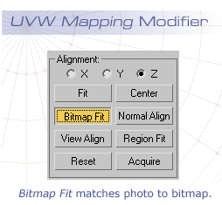
Using Maps—Image Planes
A general technique that is important to master is the use of image planes. You can remove a lot of geometry in a scene by rendering an image, deleting the geometry, and then using a simple plane mapped with the rendering.
You can use this technique with photographs as well. Let's suppose you want to have a background of the beach. Take a digital photograph, crop it to a “powers of two” texture size, and then create a plane with the same proportions.
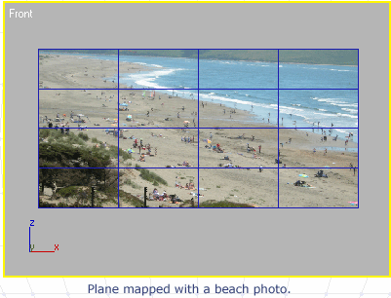
Using this method ensures that the photo won't be distorted. You can also use theBitmap Fit feature of the UVW Mapping modifier to match the texture coordinates with the proportions of the bitmap. In this case, the plane is generating its own mapping, and no modifier is used. The plane size is creating the mapping ratio of height to width.
There are many useful tools to use for alignment when you use UVW Mapping Coordinates. Region Fit lets you drag out a window to define the mapping, and normal align lets you set your mapping based on face direction by clicking on a face in the viewport. Take the time to learn these tools and you'll add power to your mapping method.
You can use level of detail (LOD) planes to replace geometry in your scene.
Let's suppose you want to have a number of palm trees in your scene now. You can place them in the scene and render them into the background using image planes.

Guest Lecture—Changing File Formats
“When I was working on a sports title the 2D paint program being used put out a new version.
Here’s a cautionary tale about upgrading your software mid-production. When I was working on a
dang sports title the 2D paint program being used put out a new version. The team got it, installed
it, and re-output the textures using the new version when lo and behold they no longer worked
in the engine!

Turned out the company had made changes to how its Targa (TGA) format was written, and the
game engine would not recognize the new version. Tried reloading the older version of the
program, which also did not like the new format, even designed the same company. Took better
part of a day to find a batch converter program that would read the new format and kick them out
in another format (in this case .bmp), which could be taken into the older version and be put out
once more as .tga. This is why a lot of times once a project starts you do not change your tools till
after the project is done.”

- Mike Dunhour
2D and 3D Expert
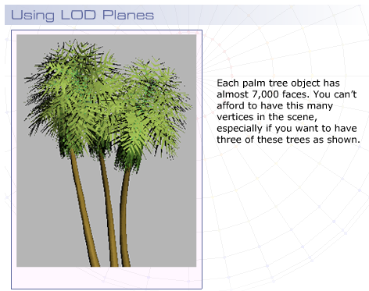
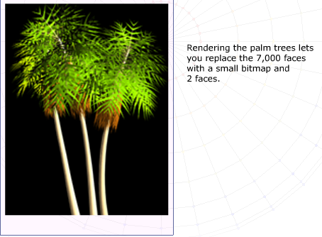
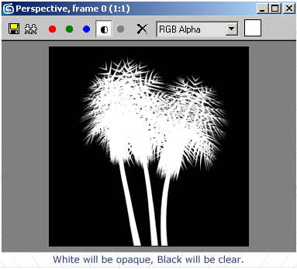
Opacity Mapping
When you have a distant figure, a prop, or a background character with a lot of detail that has to be repeated numerous times, you have a problem. You can't really create that much detail using just box modeling or spline modeling because the vertex count will become astronomical, and your game will grind to a halt.
The solution is to fake the detail using texture maps, either photo based, or paint placed on very simple boxes or planes. To do so, you use opacity mapping to create a transparency to hide the outline of the plane or box.
Using the palm tree example from the last lecture, you can create a transparency map in several ways. The easiest way is to render your image to a file format that supports an alpha transparency channel.
For example, the Targa (TGA) file format was designed for television transparency overlays. If you render your tree against an empty background, the negative space behind the tree will become completely clear in the alpha channel. You can then see the alpha channel by clicking the black and white icon in the rendered frame window.
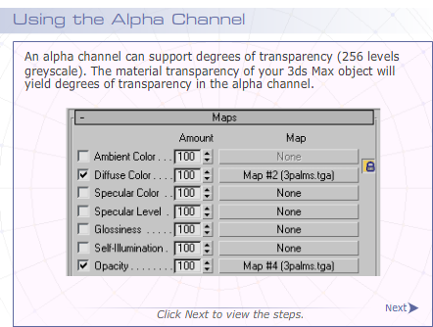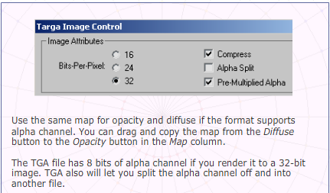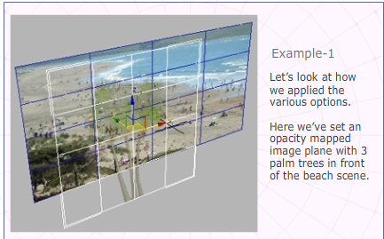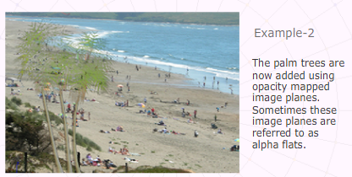
Another way to create an alpha map is to render your objects once with their true materials, and then replace those materials with a new set that has the diffuse color set to white, and Self-Illumination set to 100. Render to JPG to produce a B&W file to use as the alpha channel, and then assign it to the opacity map channel. JPGs are a 10th the size of TGA files because of their compression algorithms.
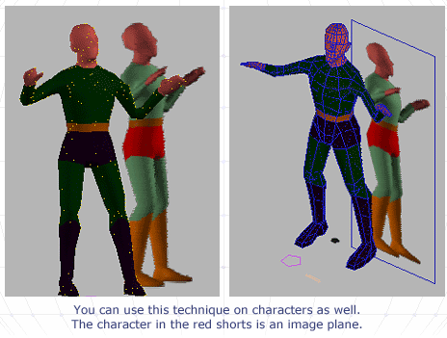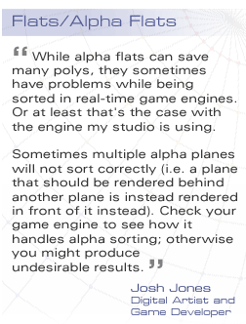

Bump and Normal Mapping
Bump Mapping and Normal Mapping are two methods to add realism to your scene geometry.

Bump Mapping
Bump Mapping gives the illusion of surface displacement without affecting the face count. Normal Mapping is a new type of bump mapping that uses 256 levels to define normal direction, so it allows for much greater detail for this type of effect.

Normal Mapping
New to 3ds Max is the ability to do normal mapping. Normal maps are enhanced bump maps specifically designed to let game developers take advantage of next generation game engine support of DirectX shaders.

[Lectures on Bump and Normal Mapping - GAD415_W4_BumpNormalMapping]

Scene Optimization—Textures vs. Geometry
There's a great two-part article that every game artist should read called, “Beautiful, Yet Friendly” by Guillaume Provost.
This article outlines performance management within a videogame level and explains what makes the performance come down, and describes the methodology to figure out when, whether, and what to optimize in your scene, while maintaining a good visual impact. This lecture covers the salient points discussed in that treatise.
The game artist is at the mercy of the game and level designer when it comes to performance. The artist can make a low-poly character that works very smoothly, but if the game designer chooses to have large numbers of these characters in the scene at once, the performance will slow down. If a game relies on portals with heavily occluded environments, the game will suffer should several portals align into view and show a large portion of the scene at once. These situations are out of the artist's control; therefore, you have to make sure your geometry is carefully optimized at the start.
If you do your job well, the game will play smoothly, and no one will think twice about performance. If, however, something causes the game animation frame rate to go down suddenly, players will scream and throw things. This scenario is not a good way to get noticed.
Provost explains you should be aware that there are three things that impact performance:
- Vertex Density: the amount of vertices displayed in a given volume
- Texture Density: the amount of textures used in a given area
- Visibility Spectrum: the set of all visible space from a given location
You can multiply these three factors together to obtain a Scene complexity quotient. The game engine will have a fixed amount of vertex and texture memory that it can use, so the greater the visibility spectrum, the less vertex and/or texture detail can be used. Level designers use portals and environment occlusion to limit the visibility spectrum, so less detail is seen at one time.
Note: Scene complexity quotient is the vertex density times the texture density times the visibility spectrum. It comes from Provost.
[Lecture on Scene complexity - GAD415_W4_GProvost]

A good general rule is to avoid too much vertex or texture density in any location. Whenever too many vertices or expensive textures come into view, they create a bottleneck for the graphics processor, causing a lag in the game play. So try to distribute texture and vertex density evenly throughout the scene. If you have costly detail, use it in an area with a lower visibility spectrum.
Some of this advice, of course, is simply common sense. Your main character will be onscreen most of the time, and you need to have more detail in the character for this reason. The extremities, hands, and feet will probably not be visible as frequently or in close up, so they can have less detail. Also objects that will be repeated as instances need to be optimized, as their contribution will be increased by a factor of the number of times they appear in the scene at once.
It helps to identify the “stress areas” or the parts of the game in which the Scene Complexity quotient is at its highest. If you have performance problems there, then you need to make adjustments either to the vertex or texture density.
Provost breaks down the problem into two parts. Either the surface is “transform bound” or “fill bound.”
When a surface is transform bound, the processor is choking on sorting the vertices. When a surface is fill bound, the drawing of the textured triangles becomes the bottleneck. Both these operations happen in parallel, so whichever is slowest determines the performance hit in the view.
By determining the bottleneck and the cost, you can tell what to optimize. Generally characters are transform bound, and environments and props are fill bound.
Two techniques that can alleviate these problems are level of detail (LOD) objects and mip-maps. These are methods that allow the game engine to swap out a higher detail object or texture for a cheaper one based on distance. When an object is sufficiently far from the camera, a LOD replacement is called up to ease the performance hit. If the distant character is going to be a handful of pixels onscreen, it can be replaced with a low-res version without visual impact. Likewise, mip-maps are used to substitute cheaper versions of textures based on distance.
In part two of the article, Provost explains that vertex count in your mesh doesn't really reflect the vertex count that is seen by the game engine. Vertices get split repeatedly, and generally speaking, the vertex count doubles or even triples within the game engine, since the graphics hardware creates surfaces from the objects based on material properties. When a vertex is on the boundary between two surfaces, the vertex is split. The same thing happens when vertices border multiple smoothing groups or UV coordinates. Building your UV mapping so there are fewer discontinuities will help avoid this problem.
In 3ds Max, both the UVW modifier and the Unwrap UVW modifiers now automatically show UV discontinuities, as green seams directly on the mesh in the viewport.
If you determine that your mesh is transform bound, you need to save on vertex splitting. You can replace detail by using normal maps to eliminate multiple smoothing groups, if your game hardware supports the use of normal mapping.
Certain game engines will take the geometry and create “strips” as a technique to avoid transforming vertices multiple times. Seek out the areas that have very thin triangles, and rearrange the vertices to avoid this type of structure. Rearranging the thin triangles will help during the stripping process.

For fill-bound objects, there are several things that contribute to poor viewport performance, and it is necessary to avoid them:
- Avoid multiple large mesh surfaces with the visibility spectrum.
- Avoid too many large transparent layers appearing at one time.
- Also avoid double sided materials, particularly on large surfaces.
Whenever possible, use diffuse colors only. Untextured surfaces draw faster than do textured ones.
VGA and NTSC Color Ranges
“VGA monitors and NTSC televisions used by consoles have a different color intensity range. A
Monitor can handle the full range of color values from 0 to 255, while television sets can not.
Black for a TV is around 9, 9, 9; and white is 250,250,250. Putting VGA textures onto a TV can
easily result in texture bleeding, where one color can bleed over onto the color next to it. This
happens especially with bright red and yellow colors, most noticeably high value reds, hence the
term bleeding.
When I started out at Ybarra Productions a long time ago, I remember we had to put some work
onto video tape to be used in a show. I put it to tape and saw red streaks everywhere. The Lead
said “Did you remember to NTSC check the textures?” Hey, it was news to me!”

Mike Dunhour
2D and 3D Expert

Summary
This past week, you reviewed the use of materials and mapping in 3ds Max. You examined the basic techniques for material creation and assignment. You also investigated multi/subobject materials and how to create them using the drag and drop technique. You also looked at some of the basic UVW mapping techniques using UVW Mapping modifier and had a chance to explore UVW Unwrap modifier as a way to assign mapping to low-poly character meshes.
This week, you've also covered the use of textures to replace geometry by using image planes and opacity mapping. You took a look at Normal mapping and how to generate normal maps, using Render to Texture and the Projection modifier.
Lastly, you learned to determine the best approach to optimize a specific scene. You determined how to tell if the problem is vertex density (transform bound) or texture-based (fill bound) and what steps to take once you've identified the source of the performance problem.
Next week, you'll learn about asset management and look into rigging, skinning, and animating your character. You'll review how to render to a still image sequence and then convert still images into a movie animation.
Assignment 1: Discussion Questions
By Tuesday, April 27, 2010, respond to the discussion question assigned to you by your facilitator. Submit your responses to the appropriate Discussion Area. Start reviewing and responding to your classmates' discussions as early in the week as possible.
Grading Criteria | Maximum Points
Response Criteria
Met the criteria for the correct responses to the questions assigned. | 6
Used vocabulary relevant to the current week's topics—at least five terms. | 6
Participation Criteria
Used vocabulary relevant to the current week's topics—at least five terms. | 6
Participated in the discussion by asking a question, providing a statement of clarification, providing a point of view with a rationale, challenging a point of discussion, or drawing a relationship between one or more points of the discussion. | 6
Justified ideas and responses by using appropriate examples and references from texts, Web sites, other references, or personal experience. | 6
Total: | 30
For assistance with any problems you may have when completing this assignment—OR—to offer your assistance to classmates, please use the Problems and Solutions Discussion area located through the left side navigation link.
Read the article, “Beautiful, Yet Friendly”, Parts 1 and 2 at and answer the following question:
What are the factors that helped you decide whether the scene optimization efforts should be texture-based or geometry-based? Do you agree with your peers responses? Why or why not?
Assignment 2: Final Project—Modeling the Level
Create an environment for your game character animation. The environment can be an interior or an exterior, but it needs to have a large expansive space that can be used for Assignment 4.
Supporting DQ: What are the techniques you used to create an environment for your game and why did you use them? Discuss the pros and cons of the techniques you used for your environment, and determine whether these techniques are different. Give reasons for your viewpoint.
Supporting DQ: What are the different ways you can use to minimize the polygon count down from 1,000? Compare and contrast the pros and cons of the various ways to minimize polygons.
By Tuesday, April 27, 2010 save your environment as a .MAX file and post it to the appropriate Discussion Area.
Review and critique the environments posted by at least two other students. Based on the feedback received from your peers, improve your game environment by the end of the week.
Grading Criteria | Maximum Points
Posted .MAX files of the environment for the game character. | 5
Mentioned the techniques used for completing the assignment and provided reasons for using them. | 10
Reviewed and critiqued the game environments of at least two other students. | 10
Total: | 25
For assistance with any problems you may have when completing this assignment—OR—to offer your assistance to classmates, please use the Problems and Solutions Discussion area located through the left side navigation link.
The first paragraph should actually refer to Assignment 3. In assignment 3 you’ll render distant objects such as rocks, trees, or lamps or columns, and replace them with the renderings applied to flat planes of geometry, to save polygons. So for this assignment, be sure to create a suitably large space that contains objects of some sort.
This assignment also asks you to critique the work of at least 2 classmates. Be sure to review the requirements for critiques outlined in the Welcome Announcement. I’ll post a brief reminder here:
Each critique must include commentary on 2 things that are working, with reasons why, and two things that are not working, with reasons why – and how they might be improved.
Also be sure to answer the discussion questions.
I look forward to reviewing your environments!
- Todd
Assignment 3: Final Project—Using Maps for Details
Merge your environment into your character max scene. Use Image Planes to create a simple background for your character. Replace the level geometry with Image Planes by rendering .TGA files and then using these files as texture maps.
Use Opacity maps to add figures and props in the distance.
By Wednesday, April 28, 2010 save the .TGA files and post them to the appropriate Discussion Area.
Grading Criteria | Maximum Points
Posted .MAX files of the environment for the game character which use image planes to replace detailed geometry. | 10
Posted .MAX files of the environment for the game character which use image planes to replace distant figures, trees, vehicles, and so on. | 15
Total: | 25
For assistance with any problems you may have when completing this assignment—OR—to offer your assistance to classmates, please use the Problems and Solutions Discussion area located through the left side navigation link.
Please post your Max files and FBX files for this assignment, along with the .tga format texture maps for the geometry, and any other texture maps you’ve applied. You’ll need to put everything in a .zip file for posting of course.
I look forward to reviewing your reduced poly environments!
- Todd
Assignment 4: Final Project—Texture Mapping Your Game Character
By Friday, April 30, 2010, add texture maps to give your character materials more interest. Paint maps as needed.
Use Bump Mapping or Normal Mapping for your character details. Post the character details in .MAX format to the appropriate Discussion Area.
Review and comment on at least two students' game characters by the end of the week.
Supporting DQ: Compare and contrast bump and normal mapping. Why did you choose one over other for detailing your characters?
Grading Criteria | Maximum Points
Posted .MAX files of their character that use texture-mapped materials. | 10
Posted .MAX files of their character that use bump or normal mapping. | 5
Reviewed and commented on at least two students' game characters. | 10
Total: | 25
For assistance with any problems you may have when completing this assignment—OR—to offer your assistance to classmates, please use the Problems and Solutions Discussion area located through the left side navigation link.
This assignment asks you to critique the work of at least 2 classmates. Be sure to review the requirements for critiques outlined in the Welcome Announcement. I’ll post a brief reminder here:
Each critique must include commentary on 2 things that are working, with reasons why, and two things that are not working, with reasons why – and how they might be improved.
Also note that you’ll need to post all of your maps as well as your max and FBX files.
Be sure to answer the discussion question.
I look forward to reviewing your texture mapped characters!
- Todd
Assignment 5: Exploring 3ds Max

Explore the 3ds Max toolset on your own. Explore the various features, actions, menus, and options of the software on your own.
By Friday, April 30, 2010, post your findings and discoveries to the Discussion Area. Also post the challenges you faced in the entire process and how you tackled those. In addition, also share some tips and best practices with your peers and suggest solutions to the challenges faced by them.
Grading Criteria | Maximum Points
Posted findings and discoveries gained while exploring the 3ds Max toolset. | 4
Actively participated in the 3ds Max Problems and Solutions Discussion Area. | 4
Total: | 8
For assistance with any problems you may have when completing this assignment—OR—to offer your assistance to classmates, please use the Problems and Solutions Discussion area located through the left side navigation link.
This assignment should be very familiar by now! Remember that this assignment asks you to explore 3D Studio Max beyond the requirements of your other assignments, and independent of those assignments. Learn something new about the software that will be useful to you, and share it with your classmates.
- Todd

